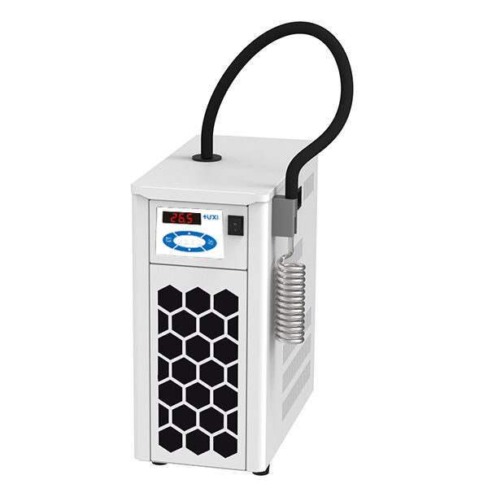

# HLT-402 Immersion coolers

**1、Application**

Immersion chiller , it through the compressor for refrigeration, through the evaporator directly with the liquid medium for heat exchange, so that the temperature of the liquid medium to reduce. At the same time the use of temperature controllers for temperature control, with constant temperature, cooling function.

**2、Features**

1. Multiple compressors stacked with advanced proportional refrigeration control technology, in the control point of the cooling capacity in proportion to the output, the compressor does not need 100% output, more energy-saving;

2. There are various forms of cold head, including rigid coil, rigid cold finger and flexible bellows. Rigid coil is suitable for heating type bath thermostatic circulator to make the temperature control below room temperature; Rigid cold finger is suitable for cold trap for solvent recovery; Flexible bellows is suitable for Dewar's bottle, glass bottle, which can be directly placed in the low-temperature freezing liquid to carry out the reaction;

3. External control signal input, can be used for external only equipment to control the start and stop of the instrument.

**3、Technical Parameters**

|  |  |
| --- | --- |
| Model | HLT-402 |
| Item No | 1040002001 |
| Temperature control range (℃) | -40~40 |
| Temperature control precision (℃) | 0.5 |
| Setting accuracy (℃) | ±0.1 |
| Display precision (℃) | ±0.1 |
| Cooling power (W) | 450 |
| Display temperature mode | LED |
| Setting mode | Membrane Keypad |
| External temperature sensor | PT100 |
| Ambient temperature (℃) | 5~32 |
| Power supply voltage (V) | 200~230 |
| Cold head size (mm) | φ50*180 |
| Hose length (mm) | 1200 |
| Overall Dimension(mm)(WxDxH) | 220*420*495 |
| Outer box size(mm)(WxDxH) | 565*375*775 |
| Net weight(kg) | 28 |
| Gross Weight(kg) | 32 |

**4、Packing List**

|  |  |
| --- | --- |
| Name | Qty |
| Main Host | 1pcs |
| Cooling coil | 1pcs |
| Manual | 1pcs |
| Temperature sensor | 1pcs |